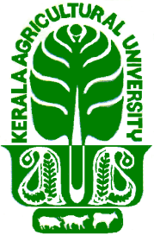 | KERALA AGRICULTURAL UNIVERSITY  CARDAMOM RESEARCH STATION, PAMPADUMPARA  IDUKKI DISTRICT, KERALA- 685 553, Ph. 04868 296163  E-mail: crspam@kau.in
CRSP(2)-1116/20 12.01.2021

NOTICE

A Walk-in-interview will be conducted on 20.01.2021 at Cardamom Research Station, Pampadumpara, to select candidates for the following temporary post on daily wages under the project “Strengthening Production of quality planting materials, T.C banana, coconut, vegetables and bio inputs in KAU”.

Name of the Post | No.  of  post | Qualification | Remuneration  (Rupees )
Skilled Assistant | 1 | M.Sc. in Life Science  (Experience in microbiological and biotechnological tools, especially in commercial production of bio-agents. Experience in the similar field for at least 1 year - desirable) | 630/day

The posting is purely temporary for 59 days from date of joining.

Interested candidates may appear for interview with originals and copy of certificates to prove qualification, date of birth, experience (if any) etc.

The interview will be at 11.30 am on 20.01.2021

Sd/-
Professor and Head

