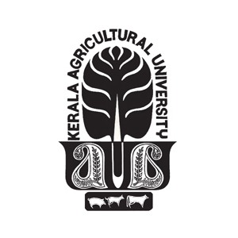
KERALA AGRICULTURAL UNIVERSITY
Main Campus, KAU P.O., Vellanikkara, Thrissur – 680 656, Kerala

No. Acad. C4/2022/101/11073 Dated:18.05.2023

NOTIFICATION

Sub: KAU – D.Edn. – Convocation-2022-Dress code for participating graduands-
Notified.

Ref: University Notification even numbered dated 03.05.2023.

*****

Vide reference cited above Kerala Agricultural University has decided to conduct the Convocation-2022 Ceremony on 03.06.2023 (Saturday) at Main Campus, KAU, Vellanikkara.
The following dress code has been prescribed for the graduands participating in the Convocation-2022 ceremony.

Boys - Black Pants, Full Sleeve White Shirt and Black Shoes.
Girls - Kerala Saree with any colour Blouse.

REGISTRAR

